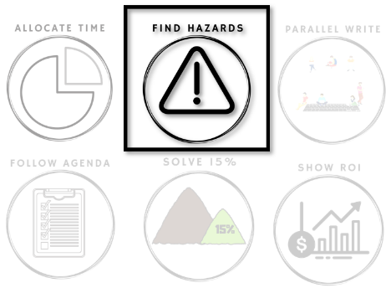
Hazards

How do we respond
when there is an issue?

How we respond to issues is the essence of Safeguarding. The most important part of that is to treat issues as data, which requires 2 behaviors. The second is to take a moderate step in response to each issue, so that our overall investment is guided by the whole set of issues not just one. And the first key behavior is to use each issue to guide work to one or two significant hazards for that issue.
Every problem arises from mistakes, but those mistakes arise more often in error prone (hazardous) environments. We can't directly prevent mistakes - asking people to be more careful or follow a process does not work - but we can make the environment less hazardous. Each time we have an issue, we want to ask "how could we be less careful next time and not have a problem?"
There are many ways a team can fail to address hazards. This week is about finding your team's pattern.

Beginning of Week: Experiment

Throughout the week you will encounter issues you would like to avoid. Examples will include:
- Bug found
- Wasting time
- Waiting
Each time you find a bug, look for the three symptoms on the tracking image below and mark which one(s) appeared.
At the end of the week, you will look for patterns in your team's symptoms.
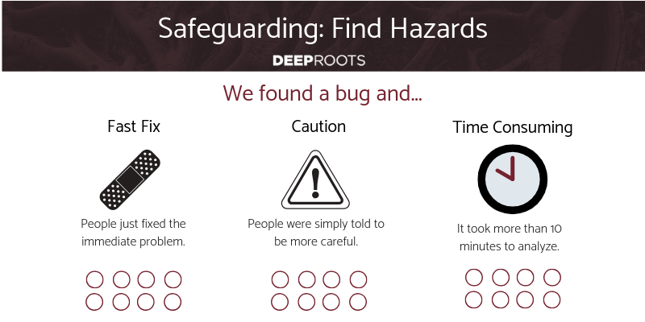
End of Week: Reflect

Finding a bug is an opportunity either to learn and prevent, or to be ashamed and try to be more careful. Which does your team do more?
Which symptoms impacted you the most often?
What work did you do in response to the bug? Anything beyond the bug fix? Why?
Can you solve your most significant symptoms yourself?
Hazard thinking addresses all 3 of these symptoms. Do you want help?

Daily Stand-Up Questions

- What is a time yesterday you had to be careful?
Weekly Retrospective Questions
This is intended to take a full 60 minute retrospective meeting.
- Sticky list all the things that went wrong this week.
- List all the contributing factors (hazards).
- Cluster according to why they aren’t solved.
- Ask which cluster hurts most in order to fix.

