Parallel Writing
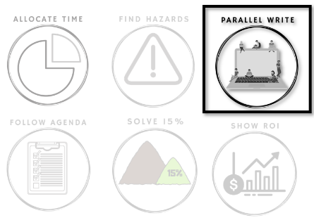

How can we explore
many directions at once?

Safeguarding requires effective group problem solving. Problem solving well requires engaging with many potential solutions. Unfortunately, most teams interact in ways that prevent even considering many solutions.
Teams are usually very good at considering the solutions that get mentioned. However, they don't notice how many potential solutions fail to get mentioned. It's impossible to know what ideas don't appear, but it is possible to look for the behaviors that block ideas.
There are many ways a team can miss out on good potential solutions. This week is about finding your team's pattern.

Beginning of Week: Experiment

This week look at all the times you get together 3 or more people and try to solve a problem.
Each time you had a problem solving meeting, look for the three symptoms on the tracking image below and mark which one(s) appeared.
At the end of the week, you will look for patterns in your team's symptoms.

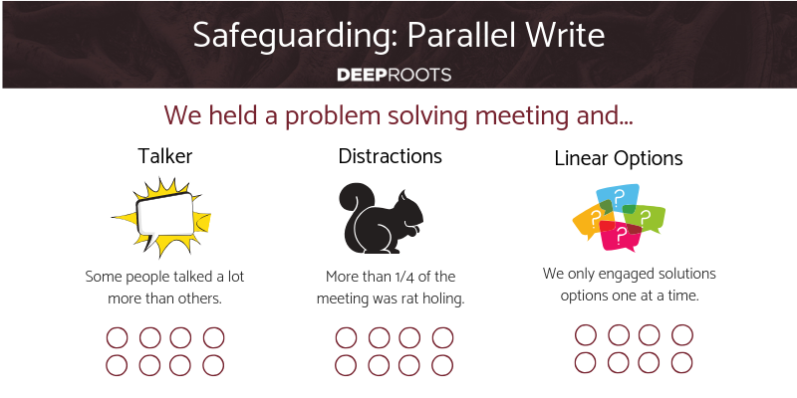
End of Week: Reflect

More than half of the good ideas usually get dropped before being said, and group problem solving still takes a long time. How many times did your team accidentally block an idea?
Which symptoms impacted you the most often?
What happened just before each symptom? What specific thing did you notice happening for each symptom? Which of these are worth addressing?
Can you solve your most significant symptoms yourself?
Parallel writing solves all 3 of these symptoms at once. Do you want help?

Daily Stand-Up Questions

- When did you have a thought that needed to be timed well?
- When did you have a thought that was off topic by the time you could contribute?
Weekly Retrospective Questions
This is intended to simply facilitate your existing retrospective meeting differently.
- Ensure all attendees participate for the remaining instructions.
- Every time you have a solution idea, write it on a sticky note without collaborating or reporting it.
- Review all the solutions afterwards.

