Follow Agenda
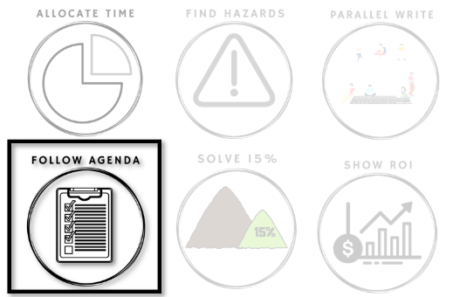

How efficiently can we
plan our Safeguards?

One of Safeguarding's key advantages is that it is efficient. Safeguarding is designed to minimize the overhead in discovering, planning, and tracking Safeguards, so that more of them get done.
This is a big difference between Safeguarding and Root Cause Analysis. RCA plans major investments all at once (more plan-driven), so efficient discovery and planning is less important. Safeguarding is incremental (more agility): it plans small investments at a time, so efficiency is critical in planning and discovery.
There are many ways a team can lose efficiency in discovery, planning, and tracking. This week is about finding your team's pattern.

Beginning of Week: Experiment

This week look at what happens after a bug is fixed.
Each time you find a bug, look for the three symptoms on the tracking image below and mark which one(s) appeared.
At the end of the week, you will look for patterns in your team's symptoms.

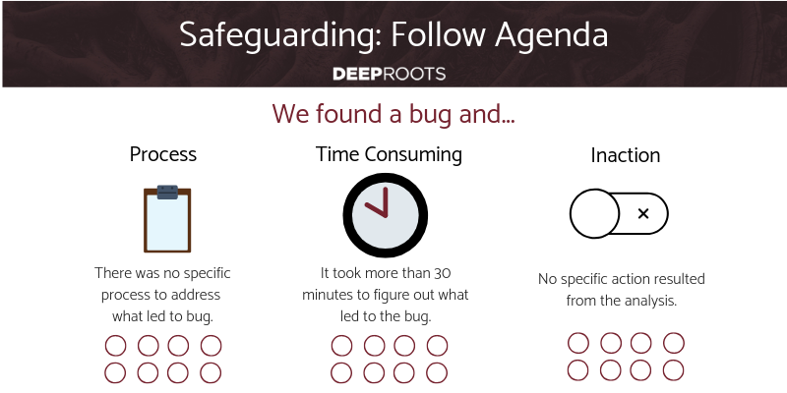
End of Week: Reflect

Efficiency means maximizing the actions taken. Well-running teams can take 2-3 Safeguarding actions per person per week. How does your efficiency compare?
Which symptoms impacted you the most often?
Do you struggle with consistent response, or is your response consistently undesirable? Do you find yourself planning more work than you could execute immediately? How much of your planned response gets executed before being prioritized against future opportunities (like features or other hazard reductions)?
Can you solve your most significant symptoms yourself?
Our Safeguarding meeting agenda solves all 3 of theses symptoms at once. Do you want help?

Daily Stand-Up Questions

- What is an achievable action you can do today towards a problem?
- What is an insight from yesterday that didn’t get captured?
Weekly Retrospective Questions
These are intended to add or replace 30m to your existing retrospective meeting agenda.
- What actions didn’t get done that were planned?
- What was imagined but no plan made?
- Which of those categories is more of an issue for the team?
- What system can you set to reliably implement your desires?

