Show ROI
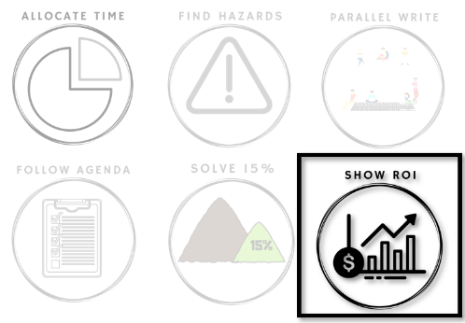

What is the business value
of technical improvements?

Every time you safeguard a Hazard, you have a chance to make it easier or harder to get support for the next safeguard. Typically, the most important support comes from people who can't understand technical Hazards. Thus it is your job to translate from the Hazard to the value.
Breaking the solution into 15% solutions is a good first step, but you still need to be able to describe the value in business terms. Usually, the key is to describe the change in risk. What risks will your safeguard reduce that your business is currently working around?
There are many ways a team can fail to align around value for safeguards. This week is about finding your team's pattern.

Beginning of Week: Experiment

Throughout the week you will fix technical debt issues and then need to show the value of your work.
Each time you find a technical debt problem, look for the three symptoms on the tracking image below and mark which one(s) appeared.
At the end of the week, you will look for patterns in your team's symptoms.

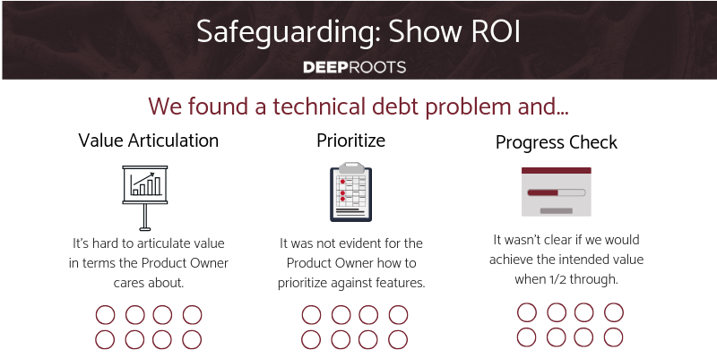
End of Week: Reflect

Each safeguard can either spark a fight of features vs code fixes, or open a discussion of risk and value. Which does your team do more?
Which symptoms impacted you the most often?
Where did you struggle to align the technical fix in terms of value? Why?
Can you solve your most significant symptoms yourself?
Risk-based RoI demos address all 3 of these symptoms. Do you want help?

Daily Stand-Up Questions

- What is the customer value of the non-story work you are doing?
- What value could you demonstrate from current work if you stopped early?
Weekly Retrospective Questions
This is intended to take a full 60 minute retrospective meeting.
- Look at all the work you completed this week.
- Make 2 groups: 1) work you did until it was done and 2) work you did until it had achieved the target value.
- Why did each story fall into the category it did? Categorize by reason.What could you do to increase the percentage of work that you do until reaching target value?

